**Installing Python on Windows**  
* We’re going to be using Python 3.  
<https://www.python.org/downloads/>  
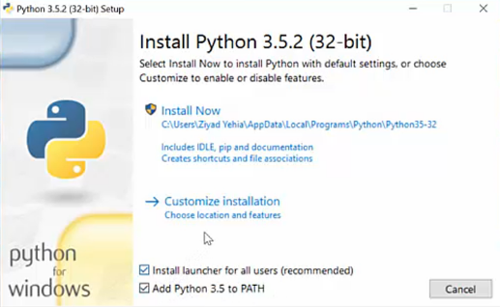  
=> **Tick the Add Python to PATH**.  
=> **Also the precompile library**.  
* **Type python in CMD and you should see the version**.

**Installing Python on Mac**  
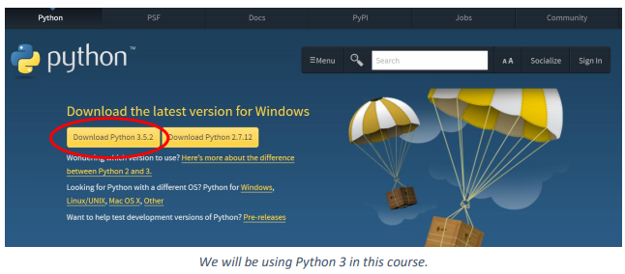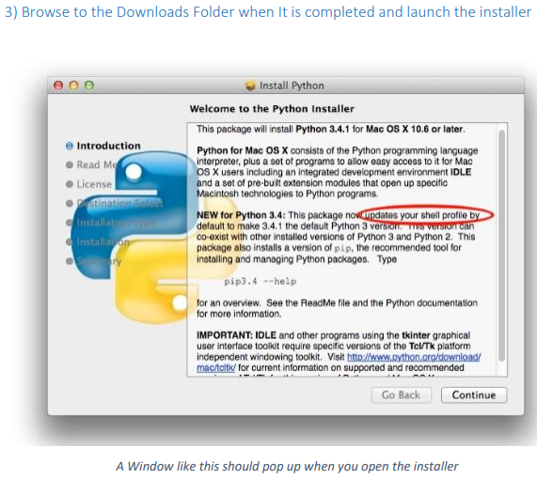

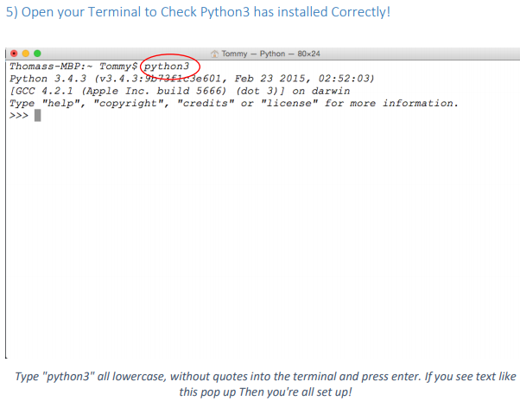

**Installing Python on Linux**  
* On most modern distributions of Linux such as Ubuntu, Mint and Fedora, Python is pretty much already installed by default.  
* Type python3 --version in a terminal.  
  
* Type python3 to get Python to work in the command line right now.  
* If you get some older value, jus type:  
**sudo apt-get upgrade** => Ubuntu  
**sudo dnf upgrade** => dnf-based distribution such as Fedora  
* If it says it’s not installed, then type:  
**sudo apt-get install python3  
sudo dnf install python3**

**Meeting IDLE | Take a tour of the Python Interactive Developer Environment (IDE)**  
* **IDE is a useful text editor that makes it easier to program in a certain programming language**.  
* We’re going to use IDLE to run python programs and write **python files = python scripts**.  
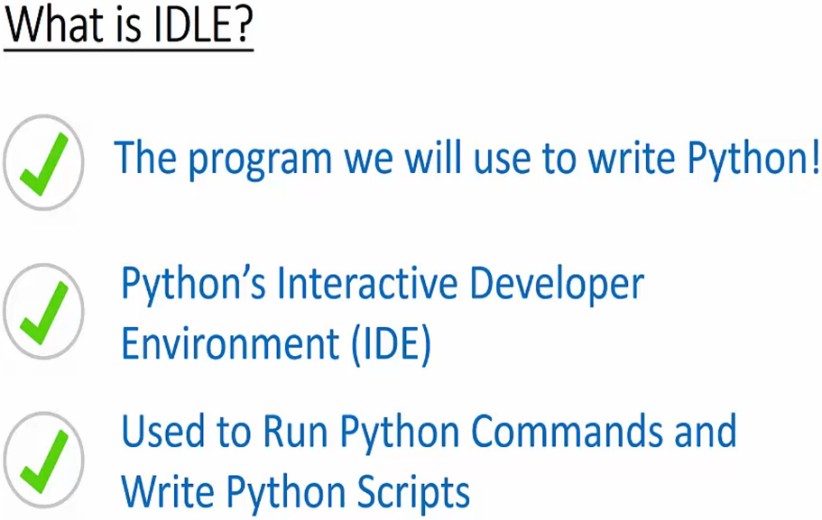  
* Type IDLE in the search.  
* **Python Shell**:  
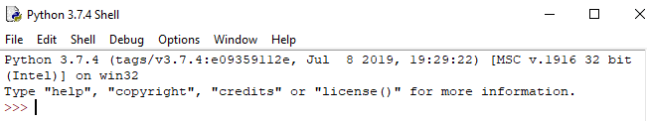  
* **Whatever you type here will be interpreted by Python as a command**.

* **File Tab** * **Help Tab**  
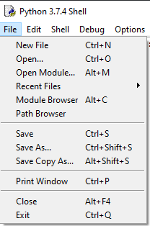 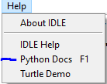  
=> **These files are Python Scripts**  
=> **The Python docs is incredibly useful**.  
* **Python Scripts** => to make our code reusable, files that we can store commands in.  
**File -> New File (CTRL + N)**  
* **Whenever you save a Python Script, make sure it has the .py file extension**.  
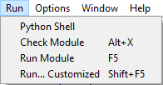  
* **In Python 3 when using Scripts, we need to do something to print something on the screen**.  
**print()**

**The Secret of Top Programmers…**  
* Secret that all top programmers know, it’s going to save you countless hours of headache.  
* It’s a really practical piece of advice that you can use all the time.  
**How to Ask Great Questions**  
* Everyone gets questions when programming no matter how awesome or experienced they are.  
* Asking questions is really just a fact of life for a programmer and learning how to ask great questions will let you fix your problems much faster and save you loads of time and headache in the process.  
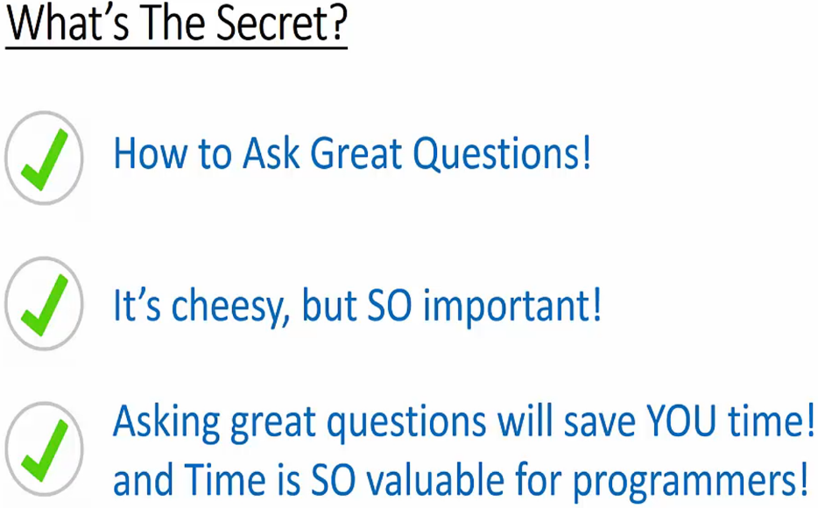 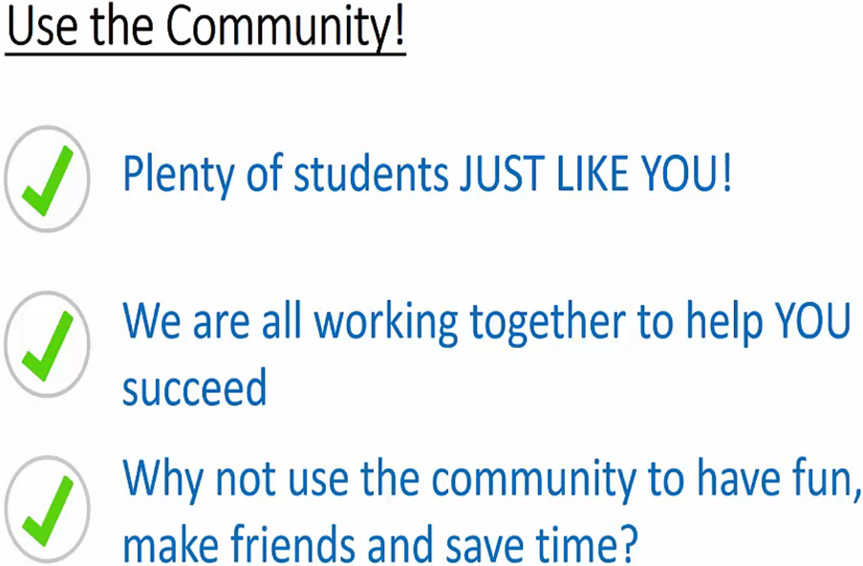  
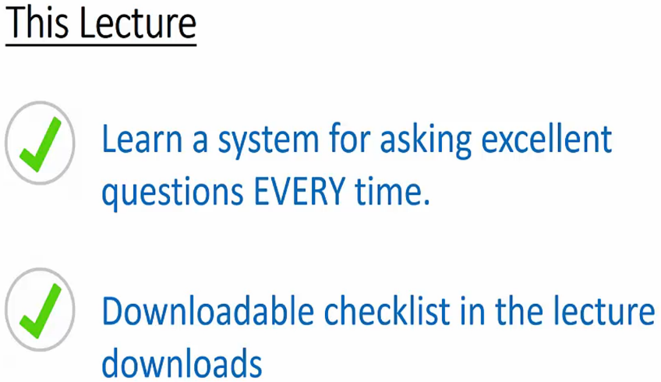

* In Udemy Q&A, use [help] when creating a question and update it to [solved] when it’s solved.  
  
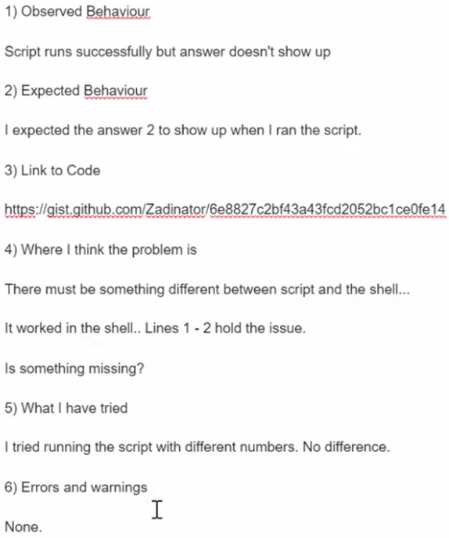  
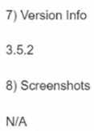

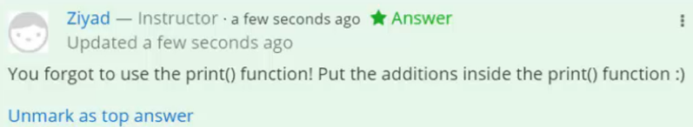

**A Quick Note**  
* Since recording this, gist.github.com now requires a free signup in order to create gists.  
* I guess the service got so popular, that github wanted to reduce the load on their servers. Maybe it was all those python bible students ;)   
* Either way, a github account is free to create, and an essential tool for every serious programmer, so go ahead and make one! :)

**Resources**  
Download Python  
<https://www.python.org/downloads/>